PS3-Lab 9
Areesha Raheel
55039

N-Queens Problem
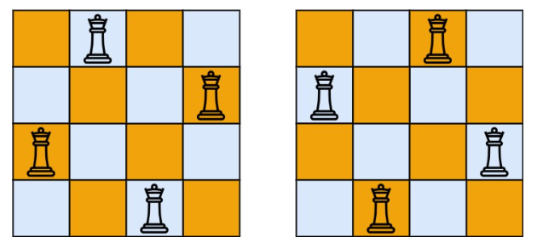
The N-Queens problem demonstrates:
- Recursion
- Backtracking
- Constraint satisfaction
- State-space search
It is one of the most important classical problems in Design & Analysis of Algorithms.
Applications
- Chess AI
- Resource allocation
- Scheduling
- Robotics sensor placement
- Surveillance systems
Advantages:
- Efficient compared to brute force
- Recursive and elegant solution
- Useful in constraint satisfaction problems

Lab Tasks:
- A security manager must place 8 cameras (queens) on an 8x8 surveillance grid (chessboard). However, due to previous infrastructure, one camera is already fixed at a specific position, for example, row 3, column 4 (using 0-indexing).

- Goal: Find a valid configuration for the remaining 7 cameras without moving the first one.
- Approach

We use the Backtracking Algorithm with a small modification:
- Place the fixed queen first
- Skip row 3 during recursion
- Continue placing queens safely in other rows
CODE:
#include <iostream>
#include <vector>
using namespace std;

const int N = 8;

// Safety Check Function
bool isSafe(vector<string>& board, int row, int col) {

// Check column
for (int i = 0; i < row; i++) {
if (board[i][col] == 'Q')
return false;
}

// Check left diagonal
for (int i = row - 1, j = col - 1;
i >= 0 && j >= 0;
i--, j--) {

if (board[i][j] == 'Q')
return false;
}

// Check right diagonal
for (int i = row - 1, j = col + 1;
i >= 0 && j < N;
i--, j++) {

if (board[i][j] == 'Q')
return false;
}

return true;
}

// Recursive Function
bool solve(vector<string>& board, int row,
int fixedRow, int fixedCol) {

// Base Case
if (row == N)
return true;

// Skip fixed queen row
if (row == fixedRow)
return solve(board, row + 1,
fixedRow, fixedCol);

// Try every column
for (int col = 0; col < N; col++) {

// Avoid placing another queen
// in fixed queen column on same row
if (board[row][col] == 'Q')
continue;

if (isSafe(board, row, col)) {

// Place Queen
board[row][col] = 'Q';

// Recursive Call
if (solve(board, row + 1,
fixedRow, fixedCol))
return true;

// Backtracking
board[row][col] = '.';
}
}

return false;
}

int main() {
vector<string> board(N, string(N, '.'));
int fixedRow = 3;
int fixedCol = 4;
// Place fixed queen
board[fixedRow][fixedCol] = 'Q';
// Solve
if (solve(board, 0, fixedRow, fixedCol)) {
cout << "Valid Configuration Found:\n\n";
for (string row : board) {
cout << row << endl;
}

} else {
cout << "No Solution Exists";
}
return 0;
}
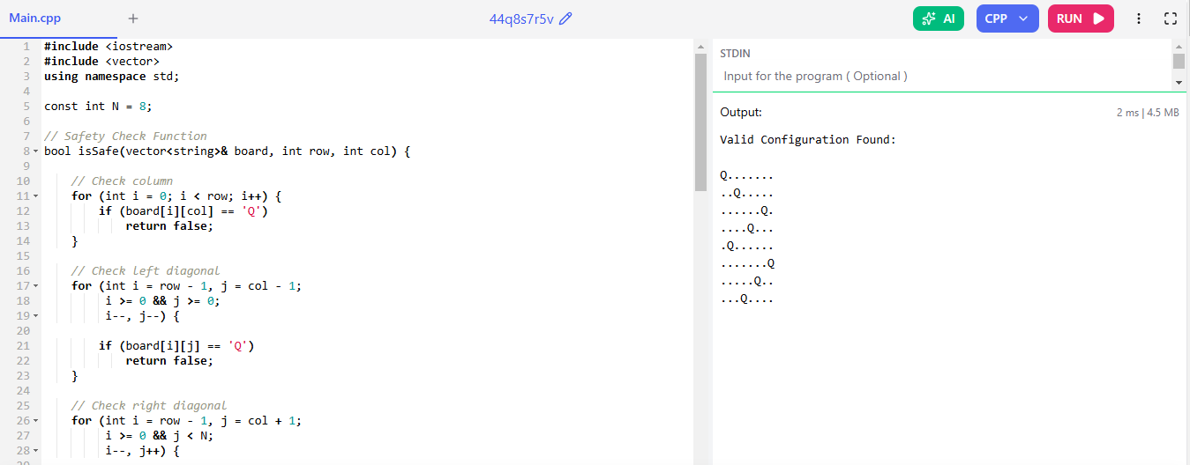
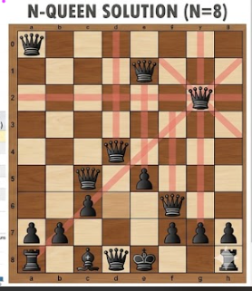

2. A city is planning to place emergency response units (queens) on a grid of districts. To save costs, the city wants to find the minimum number of units required to monitor the entire grid (where "monitoring" means covering all rows, columns, and diagonals).
Backtracking Approach
Steps
Step 1
Start with empty board.
Step 2
Place queen at best possible position.
Step 3
Mark all attacked cells:
- Row
- Column
- Diagonals
Step 4
Continue until all cells are monitored.
Step 5
Keep track of minimum queens used.

CODE:
#include <iostream>
#include <vector>
using namespace std;

const int N = 4;

vector<vector<int>> board(N, vector<int>(N, 0));

void markCells(int row, int col) {

// Mark row and column
for (int i = 0; i < N; i++) {
board[row][i] = 1;
board[i][col] = 1;
}

// Mark diagonals
for (int i = -N; i <= N; i++) {

if (row + i >= 0 &&
row + i < N &&
col + i >= 0 &&
col + i < N)

board[row + i][col + i] = 1;

if (row + i >= 0 &&
row + i < N &&
col - i >= 0 &&
col - i < N)

board[row + i][col - i] = 1;
}
}

int main() {

// Place queens manually
markCells(0,0);
markCells(2,2);

cout << "Covered Board:\n\n";

for (int i = 0; i < N; i++) {

for (int j = 0; j < N; j++) {
cout << board[i][j] << " ";
}

cout << endl;
}

return 0;
}
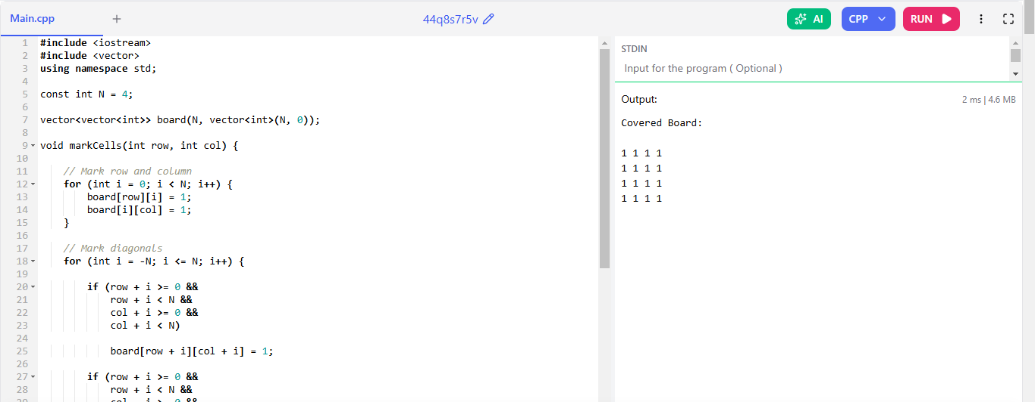

3. An incomplete game of chess has already placed k queens on the board, where k < N.

- Goal: Determine if it is possible to place the remaining N-k queens to complete a valid N-queen solution.
Approach
We use Backtracking with a modification:
- Keep already placed queens fixed
- Validate existing queens first
- Place remaining queens row by row
- Skip rows already containing queens

Algorithm Steps
Step 1
Read board with pre-placed queens.
Step 2
Check whether existing queens already conflict.
If conflict exists:
No Solution
Step 3
Start recursive backtracking.
Step 4
For each empty row:
- Try every column
- Check safety
- Place queen
- Recurse
Step 5
If all queens placed successfully:
Solution Found

CODE:
#include <iostream>
#include <vector>
using namespace std;
const int N = 4;
// Safety Check Function
bool isSafe(vector<string>& board,
int row,
int col) {

// Check column
for (int i = 0; i < N; i++) {

if (i != row &&
board[i][col] == 'Q')
return false;
}

// Left diagonal
for (int i = row - 1, j = col - 1;
i >= 0 && j >= 0;
i--, j--) {

if (board[i][j] == 'Q')
return false;
}

// Right diagonal
for (int i = row - 1, j = col + 1;
i >= 0 && j < N;
i--, j++) {

if (board[i][j] == 'Q')
return false;
}
// Lower left diagonal
for (int i = row + 1, j = col - 1;
i < N && j >= 0;
i++, j--) {

if (board[i][j] == 'Q')
return false;
}

// Lower right diagonal
for (int i = row + 1, j = col + 1;
i < N && j < N;
i++, j++) {

if (board[i][j] == 'Q')
return false;
}
return true;
}

// Check if row already has queen
bool rowHasQueen(vector<string>& board,
int row) {

for (int j = 0; j < N; j++) {

if (board[row][j] == 'Q')
return true;
}

return false;
}

// Recursive Function
bool solve(vector<string>& board,
int row) {

// Base Case
if (row == N)
return true;

// Skip rows with pre-placed queen
if (rowHasQueen(board, row))
return solve(board, row + 1);

// Try every column
for (int col = 0; col < N; col++) {

if (isSafe(board, row, col)) {

// Place queen
board[row][col] = 'Q';

// Recursive Call
if (solve(board, row + 1))
return true;

// Backtracking
board[row][col] = '.';
}
}

return false;
}

int main() {

vector<string> board = {

".Q..",
"....",
"...Q",
"...."
};

// Validate existing queens
bool valid = true;

for (int i = 0; i < N; i++) {

for (int j = 0; j < N; j++) {

if (board[i][j] == 'Q') {

board[i][j] = '.';

if (!isSafe(board, i, j)) {
valid = false;
}

board[i][j] = 'Q';
}
}
}

if (!valid) {

cout << "Initial queens are conflicting.\n";
return 0;
}

// Solve remaining board
if (solve(board, 0)) {

cout << "Valid Solution Found:\n\n";

for (string row : board) {
cout << row << endl;
}
} else {
cout << "No Solution Exists";
}
return 0;
}
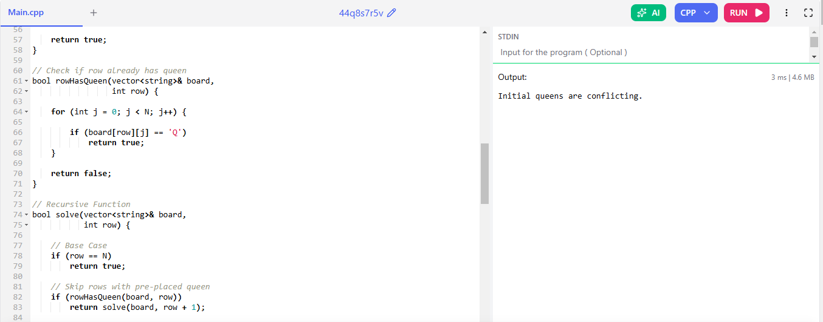

- A robotics application requires placing 6 sensors on a 6x6 board. However, certain cells are "blocked" (e.g., due to physical obstacles) and cannot hold a sensor.

- Goal: Find a valid 6-queen configuration while avoiding specific (row, col) coordinates.
Approach
We use Backtracking Algorithm with one extra condition:
Before placing a queen:
- Check if cell is blocked
- If blocked → skip

Algorithm Steps
Step 1
Initialize board with:
'.' = empty cell
'X' = blocked cell
'Q' = queen
Step 2
Start from row 0.
Step 3
For each column:
- Check blocked cell
- Check safety
- Place queen
- Recurse for next row
Step 4
If dead-end occurs:
- Remove queen
- Try next column
This is called Backtracking.
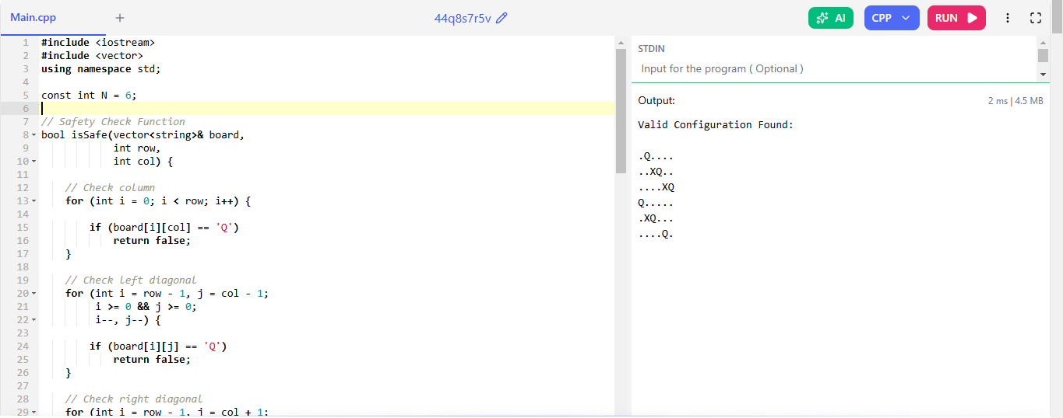

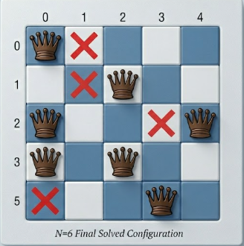

______________________________

N Queens Problem
Q1, Q2, Q3, Q4, Q5
0 1 2 3
0 |  | Q1 |  | (0,3)
1 |  |  | (1,2) | Q2
2 | Q3 | Q5 (2,1)
3 |  |  | Q4

Rules
1. No 2 queens can come in a same row
2. No 2 queens can come in a same column
3. No 2 queens can come in a diagonal (Left or right)

Algorithm
Nqueen (board [][], row, n){
If (row == n)
Return
For (i=0 to n) {
If(isValid(board, row, i) {
Board [row][i] = ‘Q’
Nqueen (board, row+1, n)
}
}
}
isValid(){
// Row
For (i=0 to n)
If ( board [row][i] = ‘Q’
return
}

// Column
For (i=0 to n)
If ( board [i][col] = ‘Q’
return
}
//Left Diagonal
For (i=row, j=col; i>=0&&j>=0; i--, j--)
If (board[i][j] =’ Q’
Return
//Right Diagonal
For (i=row, j=col; i>=0&&j<n; i--, j++)
If (board[i][j] =’ Q’)
return

